
Westside High School - Weekly Plan to Align Lessons (Week At a Glance) SY 25-26
Teacher: Subject: Course: Grade: 12/8-12/12

Standard:  Assessment: |  |  | Quiz | Unit Test | Project | Lab | None
 | Pre-Teaching  Learning Target Success Criteria 1  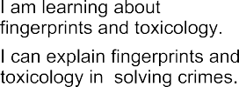  Success Criteria 2 |  |  | Activation of Learning  (5 min) | Focused Instruction  (10 min)  *I DO | Guided Instruction  (10 min)  *WE DO | Collaborative Learning  (10 min) | Independent Learning  (10 min)  *YOU DO | Closing  (5 min)
 |  |  |  | Do Now Quick Write*  Think/Pair/Share Polls Notice/Wonder Number Talks Engaging Video  Open-Ended Question | Think Aloud Visuals Demonstration Analogies* Worked Examples Nearpod Activity  Mnemonic Devices* | Socratic Seminar * Call/Response Probing Questions Graphic Organizer Nearpod Activity Digital Whiteboard | Jigsaw* Discussions* Expert Groups Labs  Stations Think/Pair/Share Create Visuals  Gallery Walk | Written Response* Digital Portfolio Presentation Canvas Assignment Choice Board  Independent Project Portfolio | Group Discussion Exit Ticket  3-2-1  Parking Lot Journaling* Nearpod
Monday |  |  |  | 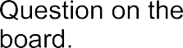 |  |  |  | 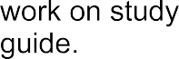
Tuesday |  |  |  | 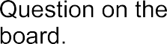 |  |  |  | 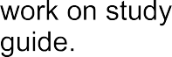
Wednesday |  | 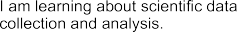 |  | 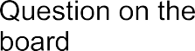 |  |  | 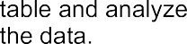
Wednesday |  | 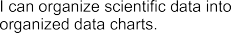
Thursday |  | 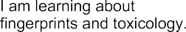 |  |  | 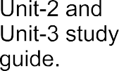 |  |  | 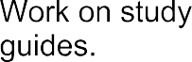 | 
Thursday |  | 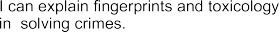
Friday |  |  |  | 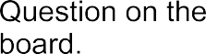 | 

Commonly used accommodations in classrooms as needed.

1. Presentation/Materials (how instruction or content is delivered)
- Provide audio supports (audiobooks, text-to-speech) for reading difficulties. educationadvanced.com+1
- Provide materials in alternative formats (large print, Braille, electronic text). Educational Equity+1
- Provide teacher lecture notes, overheads, handouts (electronic copies allowed) so the student doesn’t have to copy everything. Educational Equity+1
- Use visual aids: graphic organizers, charts, diagrams, color coding. educationadvanced.com+1
- Read aloud test directions or questions, or allow audio/visual presentation of exams. educationadvanced.com+1
- Simplify and clarify directions (both orally and in writing). InfoHub+1

2. Response/Output (how the student expresses what they know)
- Allow typed responses instead of handwriting (word processor, tablet). educationadvanced.com+1
- Use speech-to-text software or a scribe for writing tasks. educationadvanced.com+1
- Allow oral responses instead of written when appropriate. Parent Information Center+1
- Use calculators, formula sheets, spell-checkers, specialized keyboards/input devices. Educational Equity+1

3. Timing/Scheduling
- Extended time for tests, quizzes, assignments. Educational Equity+1
- Break large tasks into smaller “chunks” with separate deadlines. educationadvanced.com+1
- Frequent breaks during instruction or testing (especially for attention or fatigue issues). educationadvanced.com+1
- Adjusted schedule (e.g., testing at non-peak times, fewer distractions). educationadvanced.com+1

4. Setting/Environment
- Preferential seating (near teacher, away from distractions, close to board/screen). Educational Equity+1
- Low-distraction testing environment or alternate location. class.wfu.edu+1
- Accessible classroom location and furniture (for mobility impairments). Educational Equity+1
- Visual schedule posted, clear transitions, reduce visual/ auditory distractions. Undivided

5. Assignments/Instructional Support
- Provide extra time to complete homework or submit assignments without penalty. Undivided
- Use peer or adult note-taker, provide teacher’s notes. Educational Equity
- Use manipulatives, concrete examples, sensory materials for younger/pre-K or fine motor/physical support. InfoHub
- Provide frequent descriptive feedback, check for understanding, prompt paraphrasing. Shape America

6. Behavioral/Support/Organizational
- Provide memory aids (checklists, visual timers, graphic organizers). educationadvanced.com+1
- Use signals/cues for transitions or behavior expectations. Educational Equity
- Develop study schedule, assist with organizational strategies. Educational Equity
- Allow movement breaks or alternate sensory supports for students with ADHD/sensory needs. Undivided

7. Assistive Technology
- Text-to‐speech, speech recognition software, alternative keyboards/input devices. educationadvanced.com+1

*key literacy strategies

